Organic Dyes for Organic and Dye-Sensitized Solar Cell Applications

Wai-Yeung Wong

Department of Chemistry and Institute of Molecular Functional Materials, Hong Kong Baptist University, Waterloo Road, Kowloon Tong, Hong Kong, P.R. China.
E-mail: rwywong@hkbu.edu.hk

Organic molecules have become a field of intense activities in the photovoltaic research. They hold great promise as versatile functional materials for use as absorbers and photosensitizers in solar energy harvesting. This lecture highlights the recent progress in the advances of numerous functional organic dyes in organic and dye-sensitized solar cells for solar power generation. The strategies based on structural modifications of the organic groups to tune the photovoltaic properties of these materials will be presented and discussed.

References:
- C. Cui, J. Min, C.-L. Ho, T. Ameri, P. Yang, J. Zhao, C.J. Brabec, W.-Y. Wong, Chem. Commun. 2013, 49, 4409; (2) Q. Liu, H. Zhan, C.-L. Ho, F.-R. Dai, Y. Fu, Z. Xie, L. Wang, J.-H. Li, F. Yan, S.-P. Huang, W.-Y. Wong, Chem. Asian J. 2013, 8, 1892; (3) D. Ye, X. Li, L. Yan, W. Zhang, Z. Hu, Y. Liang, J. Fang, W.-Y. Wong, X. Wang, J. Mater. Chem. A 2013, 1, 7622; (4) Y. Hua, S. Chang, D. Huang, X. Zhou, X. Zhu, J. Zhao, T. Chen, W.-Y. Wong, W.-K. Wong, Chem. Mater. 2013, 25, 2146; (5) C. Qin, W.-Y. Wong, L. Han, Chem. Asian J. 2013, 8, 1706; (6) Y. Hua, B. Jin, H. Wang, X. Zhu, W. Wu, M.-S. Cheung, Z. Lin, W.-Y. Wong, W.-K. Wong, J. Power Sources 2013, 237, 195; (7) S. Chang, H. Wang, Y. Hua, Q. Li, X. Xiao, W.-K. Wong, W.-Y. Wong, X. Zhu, T. Chen, J. Mater. Chem. A 2013, 1, 11553.

Biography
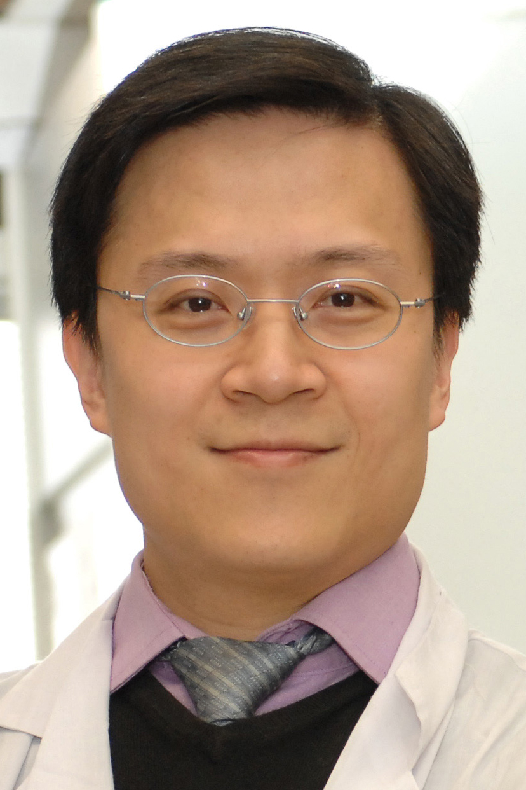 | Wai-Yeung Wong received BSc (1992) and PhD (1995) degrees from the University of Hong Kong with the PhD work under the tutelage of Prof. Wing-Tak Wong. After a postdoctoral year with Prof. F. Albert Cotton in Texas A&M University in 1996, he worked for Profs. The Lord Jack Lewis (FRS) and Paul R. Raithby at the University of Cambridge in 1997. He joined Hong Kong Baptist University as an Assistant Professor in 1998, rising through the academic ranks to Chair Professor in Chemistry in early 2011. Professor Wong is internationally renowned for his research in metallopolymers and metallo-organic molecules with energy functions and photofunctional properties. He has made profound contributions in the field of organometallic optoelectronics and photovoltaics. His research focuses on synthetic inorganic and organometallic chemistry and structural chemistry, with special emphasis on developing novel molecular functional materials and polymers containing late transition metal elements, setting a common goal especially towards advancing energy-related technologies.  He has a distinguished publication record of ~400 scientific articles to date and his current h-index is 53. He becomes the first Chinese scientist to be presented with the Chemistry of the Transition Metals Award by the Royal Society of Chemistry in 2010. He is also the recipient of the First Class Prize in Natural Science Award from Ministry of Education of China in 2010 and the FACS Distinguished Young Chemist Award in 2011, and has won the Distinguished Lectureship Award from The Chemical Society of Japan in 2012. Recently, he was also awarded the Ho Leung Ho Lee Foundation Prize for Scientific and Technological Innovation in 2012. Professor Wong is currently the Associate Editor of Journal of Materials Chemistry C and Regional Editor of Journal of Organometallic Chemistry, and serves on the editorial/international advisory boards of numerous international scientific journals including Dalton Transactions, Dyes and Pigments, Macromolecular Rapid Communications, Macromolecular Chemistry & Physics, Comments on Inorganic Chemistry, Journal of Inorganic & Organometallic Polymers & Materials, and Current Organic Chemistry, etc. At present, he is also the Chairman of the Hong Kong Chemical Society.

